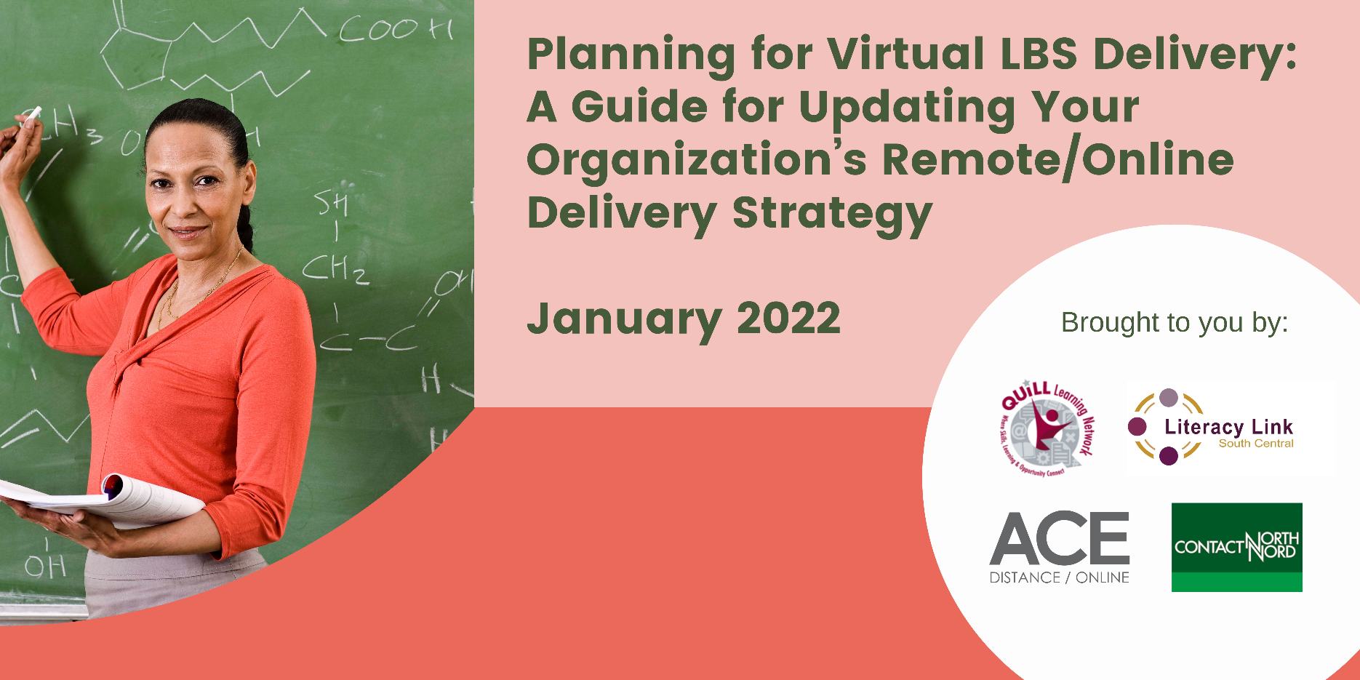

## Introduction

The checklist and workbook in this package were introduced at the January 13, 2022 webinar, *Planning and Collaboration for Virtual LBS Delivery,* available [here](https://can01.safelinks.protection.outlook.com/?url=https%3A%2F%2Fe-channel.ca%2Fpractitioners%2Fvirtual-delivery&data=04%7C01%7CExecutiveDirector%40CSCAU.com%7C0ad30c898fed46e8d6ef08d9d7a40d0f%7C0cff09b4305e4c88b2917f9df018f4d0%7C0%7C0%7C637777921854301818%7CUnknown%7CTWFpbGZsb3d8eyJWIjoiMC4wLjAwMDAiLCJQIjoiV2luMzIiLCJBTiI6Ik1haWwiLCJXVCI6Mn0%3D%7C3000&sdata=1Ak48N9pwvkYY8ym1jX1%2Fh2NVK38OMHmaSstmqz%2Bt24%3D&reserved=0) on Contact North’s website. These materials are not provided by the MLTSD. They are adapted for LBS from a webinar (March 2021) entitled, *How to Ensure Success in Online Learning Programs,* delivered by Dr. Darcy Hardy, Associate Vice President for Academic Affairs at Blackboard Inc. Dr. Hardy’s webinar was part of Contact North’s online professional development series and can be accessed at [teachonline.ca](https://teachonline.ca/webinar/how-ensure-success-online-learning-programs)

Note that in this checklist/workbook, the term “virtual” delivery refers to the following:

* Programming for learners that allows them to engage remotely for some components of their learning.

## Using the Checklist and Workbook

The items included in the checklist are intended to be a **guideline** for discussion and planning for your LBS program. The checklist is the “short version”; the workbook contains all items from the checklist but also provides extra space to make notes.

The extent to which the checklist items apply to your LBS organization depends on how much of your program delivery you wish to offer in a virtual model. It also depends on the resources (financial and human) that you can commit to virtual delivery. Some items apply only (or more significantly) to fully online delivery offered by the five LBS e-Channel programs. Those items are highlighted in yellow. You may want to add other items to the checklist that are specific to your LBS program and approach to virtual delivery.

## Part 1: Checklist - Planning for LBS Virtual Delivery

1. **Does our organization have strategies for delivery of a virtual model that include the following?**

* Planning for growth (not just more learners, but program innovation)
* Targeting learner population(s) - current, new, specific group
* Identifying content to be available virtually (specific courses/curriculum)
* Planning to include shared materials/resources created by other organizations
* Integrating asynchronous and/or synchronous delivery

1. **Does our strategy include a plan for purchasing/accessing/maintaining technologies, including the following, if needed?**

* Collaboration tools (e.g. Zoom, MS Teams) and document sharing sites (e.g. Google Docs, OneDrive)
* Reliable hardware, software, and internet access (staff and learners)
* Technical support (staff and learners)
* A Learning Management System (LMS) and upgrades as needed
* Authoring software (H5P, Articulate Rise, Storyline, Captivate, etc.)
* Instructional design/development support, e.g. within an LMS

1. **Do we have policies and processes in place that reflect our strategies, including the following?**

* Code of conduct (“netiquette”) for learners and staff re virtual participation and communication, e.g. email, messaging, chats, video conferencing,
* Expectations for learner participation/attendance/communication
* Expectations for instructor response time, marking assignments, etc.
* Accessibility/accommodations for learners working virtually
* Quality standards for online content development, including AODA compliance and universal design for learning (UDL) principles
* Guidelines for online instructional design best practices (branding, layout, navigation, assessment, etc.)
* Data-driven evaluation plan for measuring success

1. **Does our virtual delivery plan and business process map include the following?**

* Learner readiness checklist (tech specs, communication platforms, etc.)
* Intake process, assessment, orientation
* Placement appropriate to learner’s needs/level
* Learner retention strategy (for both program and courses)
* Learner support services (advising/counselling, technical support, list of alternative access sites for learners with limited or no at-home connectivity, etc.)
* Multi-channel communications plan (best practices for virtual delivery)

1. **Does our staffing model include the following?**

* Qualifications/job description(s) to reflect virtual delivery requirements
* Differentiation between staff and/or duties for virtual and in-person delivery
* Opportunities and resources for professional development for virtual teaching/learning (paid release time, adequate funds, etc.)

## Part 2: Workbook - Planning for LBS Virtual Delivery

|  |  |
| --- | --- |
| 1. **Does our organization have strategies for delivery of a virtual model that include the following?** | |
| □ Yes  □ No  □ Needs work | 1. Planning for growth (not just more learners, but program innovation) |
| Notes | |
| □ Yes  □ No  □ Needs work | 1. Targeting learner population(s) - current, new, specific group |
| Notes | |
| □ Yes  □ No  □ Needs work | 1. Identifying content to be available virtual (specific courses/curriculum) |
| Notes | |
| □ Yes  □ No  □ Needs work | 1. Planning to include shared materials/resources created by other organizations |
| Notes | |
| □ Yes  □ No  □ Needs work | 1. Integrating asynchronous and/or synchronous delivery |
| Notes | |

|  |  |
| --- | --- |
| 1. **Does our strategy include a plan for purchasing/accessing/maintaining technologies, including the following, if needed?** | |
| □ Yes  □ No  □ Needs work | 1. Collaboration tools (e.g. Zoom, MS Teams) and document sharing sites (e.g. Google Docs, OneDrive) |
| Notes | |
| □ Yes  □ No  □ Needs work | 1. Reliable hardware, software, & internet access (staff and learners) |
| Notes | |
| □ Yes  □ No  □ Needs work | 1. Technical support for both staff and learners |
| Notes | |
| □ Yes  □ No  □ Needs work | 1. Learning Management System (LMS) and upgrades as needed |
| Notes | |
| □ Yes  □ No  □ Needs work | 1. Authoring software (H5P, Articulate Rise, Storyline, Captivate, etc.) |
| Notes | |
| □ Yes  □ No  □ Needs work | 1. Instructional design/development support |
| Notes | |

|  |  |
| --- | --- |
| 1. **Do we have policies and processes in place that reflect our strategies, including the following?** | |
| □ Yes  □ No  □ Needs work | 1. Code of conduct (“netiquette”) for learners and staff re virtual participation and communication, e.g. email, messaging, chats, video conferencing |
| Notes | |
| □ Yes  □ No  □ Needs work | 1. Expectations for learner participation/attendance/communication |
| Notes | |
| □ Yes  □ No  □ Needs work | 1. Accessibility/accommodations for learners working virtually |
| Notes | |
| □ Yes  □ No  □ Needs work | 1. Quality standards for virtual content development, including AODA compliance and universal design for learning (UDL) principles |
| Notes | |
| □ Yes  □ No  □ Needs work | 1. Guidelines for online instructional design best practices (branding, layout, navigation, assessment, etc.) |
| Notes | |
| □ Yes  □ No  □ Needs work | 1. Data-driven evaluation plan for measuring success |
| Notes | |

|  |  |
| --- | --- |
| 1. **Does our virtual delivery plan include the following?** | |
| □ Yes  □ No  □ Needs work | 1. Learner readiness checklist (tech specs, communication platforms, etc.) |
| Notes | |
| □ Yes  □ No  □ Needs work | 1. Intake process, assessment, orientation |
| Notes | |
| □ Yes  □ No  □ Needs work | 1. Placement appropriate to learner’s needs/level |
| Notes | |
| □ Yes  □ No  □ Needs work | 1. Learner retention strategy (for program and courses) |
| Notes | |
| □ Yes  □ No  □ Needs work | 1. Learner support services (advising/counselling, technical support, list of alternative access sites for learners with limited or no at-home connectivity, etc.) |
| Notes | |
| □ Yes  □ No  □ Needs work | 1. Multi-channel communications plan (best practices for virtual delivery) |
| Notes | |

|  |  |
| --- | --- |
| 1. **Does our staffing model include the following?** | |
| □ Yes  □ No  □ Needs work | 1. Qualifications/job description(s) to reflect virtual delivery requirements |
| Notes | |
| □ Yes  □ No  □ Needs work | 1. Differentiation between staff and/or duties for virtual and in-person delivery |
| Notes | |
| □ Yes  □ No  □ Needs work | 1. Opportunities and resources for professional development for virtual teaching/learning (paid release time, adequate funds, etc.) |
| Notes | |